Assignment 10 (S-520)

FNU Anirudh

November 19, 2015

Solution 1

A<- c(37.54,37.01,36.71,37.03,37.32,37.01,37.03,37.70,37.36,36.75,37.45,38.85)  
B<- c(40.17,40.80,39.76,39.70,40.79,40.44,39.79,39.38)  
C<- c(39.04,39.21,39.05,38.24,38.53,38.71,38.89,38.66,38.51,40.08)  
ALL<-c(A,B,C)  
boxplot(A,B,C,main="Box Plot of A,B and C",names=c('A','B','C'),col =   
 c("Green","Blue","Yellow"))

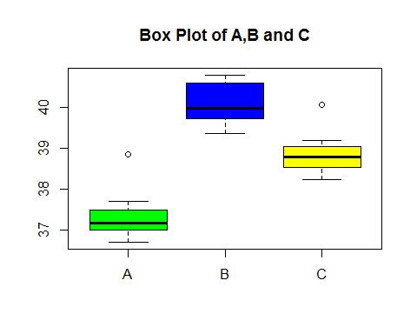

# Check Normality  
qqnorm(A,main="QQ Plot for Sample A")

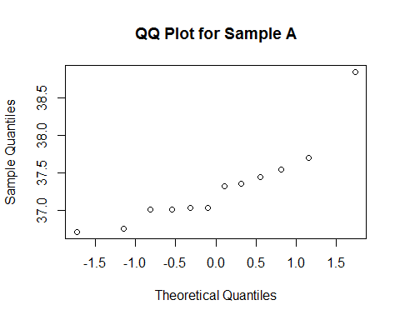

qqnorm(B,main="QQ Plot for Sample B")

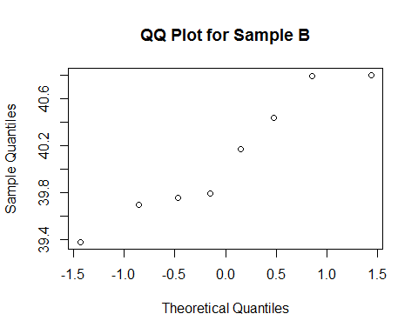

qqnorm(C,main="QQ Plot for Sample C")

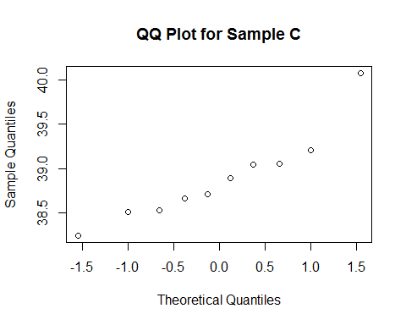

n1=length(A)  
n2=length(B)  
n3=length(C)  
N=n1+n2+n3  
# Check homoscedasticity  
sda=sd(A)  
sdb=sd(B)  
sdc=sd(C)  
sda

## [1] 0.5727975

sdb

## [1] 0.5313846

sdc

## [1] 0.510812

# Assumptions of Normality:-  
# The distribution resembles closer to normality for sample B though   
# location of median may question it's symmetry and normal distribution.   
# We cannot conclude that data is normally distributed. Sample A and C are pretty much symmetric and have outliers that questions normal distribution.  
# Assumption of Homoscedasticity:-  
# Standard Deviation of all the samples are more or less equal  
# Hence Homoscedasticity assumption is quite plausible.  
meana=mean(A)  
meanb=mean(B)  
meanc=mean(C)  
grand.mean=mean(ALL)  
  
# Total Sum of Squares  
SST = sum( (ALL-grand.mean)^2 )  
total.df = N - 1  
  
# Between sum-of-squares and mean-square  
SSB = n1*(meana-grand.mean)^2 +  
 n2*(meanb-grand.mean)^2 +  
 n3*(meanc-grand.mean)^2  
between.df = 2   
between.meansquare = SSB/2  
  
# Within sum-of-squares and mean-square  
SSW = sum( (A-meana)^2 ) +  
 sum( (B-meanb)^2 ) +  
 sum( (C-meanc)^2 )  
# Alternative formula  
SSW = (n1-1)*var(A) +  
 (n2-1)*var(B) +  
 (n3-1)*var(C)  
within.df = N - 3  
within.meansquare = SSW/within.df  
  
# Check these are equal  
SST

## [1] 46.7349

SSB + SSW

## [1] 46.7349

# The two are equal.  
  
# Are these close?  
between.meansquare

## [1] 19.40044

within.meansquare

## [1] 0.2938524

# F-test  
F = between.meansquare/within.meansquare  
# P-value  
P=1 - pf(F, df1=between.df, df2=within.df)  
  
sites<-c(between.df,round(SSB,4),round(between.meansquare,4),round(F,4),round(P,4))  
residuals<-c(within.df,round(SSW,4),round(within.meansquare,4),"-","-")  
ANOVA<-as.data.frame(rbind(sites,residuals))  
rownames(ANOVA)<-c("SITES","RESIDUALS")  
colnames(ANOVA)<-c("Df","Sum.sq","Mean.sq","F:Value","Pr(>F)")  
ANOVA

## Df Sum.sq Mean.sq F:Value Pr(>F)  
## SITES 2 38.8009 19.4004 66.021 0  
## RESIDUALS 27 7.934 0.2939 - -

p = 4.008649e-11 < ALPHA = 0.05---> reject H0

Since p value is so small hence we reject the Null Hypothesis.

Solution 2

x1<- c(124,42,25,45,412,51,1112,46,103,876,146,340,396)  
x2<- c(81,461,20,450,246,166,63,64,155,859,151,166,37,223,138,72,245)  
x3<- c(248,377,189,1843,180,537,519,455,406,365,942,776,372,163,101,20,  
 283)  
x4<- c(1234,89,201,356,2970,456)  
x5<- c(1235,24,1581,1166,40,727,3808,791,1804,3460,719)  
X<- c(x1,x2,x3,x4,x5)  
y1<- log(x1)  
y2<- log(x2)  
y3<- log(x3)  
y4<- log(x4)  
y5<- log(x5)  
Y<- c(y1,y2,y3,y4,y5)  
n1=length(x1)  
n2=length(x2)  
n3=length(x3)  
n4=length(x4)  
n5=length(x5)  
N=n1+n2+n3+n4+n5  
par(mfrow=c(1,2))  
boxplot(x1,x2,x3,x4,x5,main="Box Plot of X",names = c("X1","X2","X3","X4","X5"),col=c("Red","Blue","Green","Yellow","Orange"))  
boxplot(y1,y2,y3,y4,y5,main="Box Plot of Log(X)",  
 names = c("Y1","Y2","Y3","Y4","Y5"),col=c("Red","Blue","Green",  
 "Yellow","Orange"))

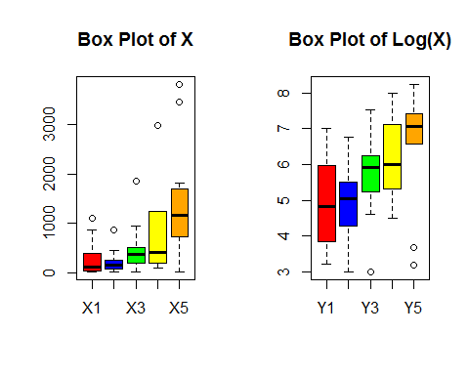

# Assumptions of Normality:-  
# As seen from Box Plot, All X- Values have outliers and doesn't look  
# normally distributed looking at median values. Box plot of Log values  
# look little closer to normal distribution specially Y1. (Y2 AND Y4 being close) hence Y1,Y2 and Y4 can be considered normal. Log values  
# can be assumped to satisfy ANOVA assumptions.  
  
sdx1=sd(x1)  
sdx2=sd(x2)  
sdx3=sd(x3)  
sdx4=sd(x4)  
sdx5=sd(x5)  
sdy1=sd(y1)  
sdy2=sd(y2)  
sdy3=sd(y3)  
sdy4=sd(y4)  
sdy5=sd(y5)  
# Assumptions Homoscediasticity  
# Looking at the values of Standard Deviation there is a some difference  
# in values for X whereas there is not much difference in values for Y  
# Hence Homoscediasticity is plausible for Y.  
  
#Let Ho be that mean survival time be same for different organ affected #Let Ha be that mean survival time be different for at least one organ affected  
  
y1m = mean(y1)  
y2m = mean(y2)  
y3m = mean(y3)  
y4m = mean(y4)  
y5m = mean(y5)  
grand.mean = mean(Y)  
k=5  
  
SST = sum( (Y-grand.mean)^2 )  
total.df = N - 1  
  
SSB = n1*(y1m-grand.mean)^2 +  
 n2*(y2m-grand.mean)^2 +  
 n3*(y3m-grand.mean)^2 +   
 n4*(y4m-grand.mean)^2 +  
 n5*(y5m-grand.mean)^2  
between.df = k-1   
between.meansquare = SSB/between.df   
SSW = sum( (y1-y1m)^2 ) +  
 sum( (y2-y2m)^2 ) +  
 sum( (y3-y3m)^2 )+ sum((y4-y4m)^2)+sum((y5-y5m)^2)  
within.df = N - k  
within.meansquare = SSW/within.df  
  
F = between.meansquare/within.meansquare  
# P-value  
P=1 - pf(F, df1=between.df, df2=within.df)  
  
organs<-c(between.df,round(SSB,4),round(between.meansquare,4),round(F,4),round(P,4))  
residuals<-c(within.df,round(SSW,4),round(within.meansquare,4),"-","-")  
ANOVA<-as.data.frame(rbind(organs,residuals))  
rownames(ANOVA)<-c("Organs","Residuals")  
colnames(ANOVA)<-c("Df","Sum.sq","Mean.sq","F:Value","Pr(>F)")  
ANOVA

## Df Sum.sq Mean.sq F:Value Pr(>F)  
## Organs 4 24.4866 6.1216 4.286 0.0041  
## Residuals 59 84.2696 1.4283 - -

P = 0.004121 < ALPHA = 0.05---> reject H0

Since P-value is so small, we reject Null Hypothesis.

Solution 3

stereograms = read.table(file.choose(), header=TRUE)  
treatment = stereograms$time[stereograms$group==2]  
control = stereograms$time[stereograms$group==1]  
all.diffs<-stereograms$time  
t.test(treatment, control)

##   
## Welch Two Sample t-test  
##   
## data: treatment and control  
## t = -2.0384, df = 70.039, p-value = 0.04529  
## alternative hypothesis: true difference in means is not equal to 0  
## 95 percent confidence interval:  
## -5.95314090 -0.06493219  
## sample estimates:  
## mean of x mean of y   
## 5.551429 8.560465

n1 = length(treatment)  
n2 = length(control)  
N=n1+n2  
k=2  
boxplot(treatment, control, range=0,   
 names=c("Treatment","control"),  
 ylab="Time",col=c("Red","Green"))

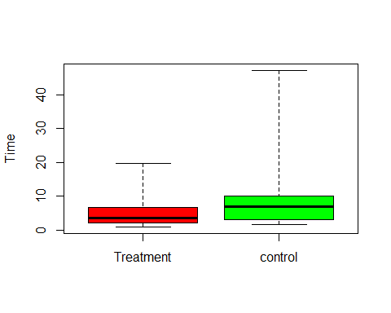

sd(treatment)

## [1] 4.801738

sd(control)

## [1] 8.085411

qqnorm(treatment,main="QQ Plot of Treatment")

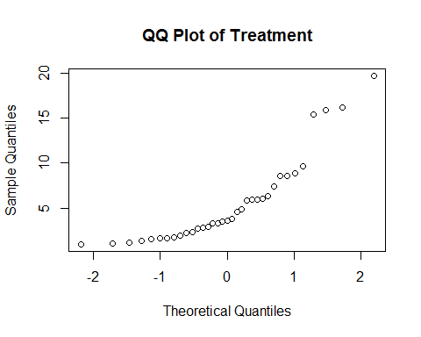

qqnorm(control,main="QQ Plot of Control")

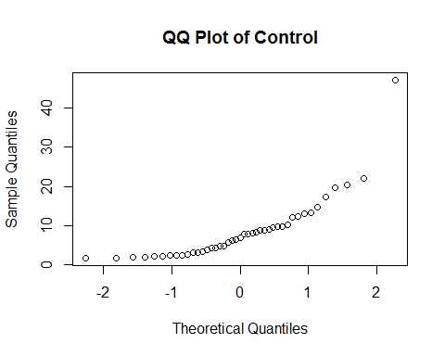

tmean = mean(treatment)  
cmean = mean(control)  
grand.mean = mean(all.diffs)  
SST = sum( (all.diffs-grand.mean)^2 )  
total.df = N - 1  
SSB = n1*(tmean-grand.mean)^2 +  
 n2*(cmean-grand.mean)^2   
   
between.df = k-1   
between.meansquare = SSB/between.df  
SSW = sum( (treatment-tmean)^2 ) +  
 sum( (control-cmean)^2 )   
  
  
within.df = N - k  
within.meansquare = SSW/within.df  
  
F = between.meansquare/within.meansquare  
# P-value  
p=1 - pf(F, df1=between.df, df2=within.df)  
  
group<-c(between.df,round(SSB,3),round(between.meansquare,3),round(F,3),round(p,5))  
residuals<-c(within.df,round(SSW,3),round(within.meansquare,3),"-","-")  
ANOVA<-as.data.frame(rbind(group,residuals))  
rownames(ANOVA)<-c("Group","residuals")  
colnames(ANOVA)<-c("Df","Sum.sq","Mean.sq","F:Value","Pr(>F)")  
ANOVA

## Df Sum.sq Mean.sq F:Value Pr(>F)  
## Group 1 174.702 174.702 3.762 0.05615  
## residuals 76 3529.63 46.443 - -

P- Value comes close to Student t-test value.